
MINISTRY OF ENERGY AND PETROLEUM
State Department for Petroleum

REPORT ON SYSTEM BENCHMARKING EXERCISE

HELD ON

19TH MARCH 2026
AT
KENYA PIPELINE COMPANY (KPC)
HEADQUARTERS

1.0 INTRODUCTION
The development of an effective and sustainable system requires a clear understanding of existing solutions and industry best practices. To support this process, a benchmarking exercise was conducted at Kenya Pipeline Company (KPC) headquarters.
The purpose of this exercise was to evaluate the performance, structure, and functionality of an existing system and to draw lessons that can inform the development of the Unified Petroleum Exploration and Monitoring Management Information System (UPEMMIS). This report documents the process, findings, and recommendations derived from the exercise.
1.1 Objectives of the Exercise
The key objectives of the benchmarking exercise were:
- To assess the architecture and functionality of an existing system
- To identify best practices and success factors
- To highlight gaps and challenges in current implementations
- To generate recommendations for improving system design
- To inform and strengthen the Terms of Reference
1.2 Scope
The benchmarking exercise focused on the following areas:
- Pipeline Monitoring and Control Systems (incl. SCADA Integration)
- Enterprise Resource Planning (ERP) systems & workflow Automation
- Assets Management & Maintenance Systems
- Revenue Management & Financial System Integration
- ICT Infrastructure
- Cybersecurity framework
- Data Governance & Reporting Mechanisms
- Implementation Strategies and Lessons learned
2.0 Participants
The exercise was conducted by a team from KPC, Petroleum officers and State Department for Petroleum’s ICT team.
3.0 Methodology
The exercise was conducted by KPC ICT team, and the following methods were adopted:
- PowerPoint presentations.
- Discussions with system users, administrators, and technical staff
- Examination of system features, workflows, and interfaces
- Question-and-answer sessions
4.0 Key areas of assessment
4.1 Pipeline Monitoring and Control Systems (incl. SCADA Integration)
KPC operates advanced SCADA (Supervisory Control and Data Acquisition) systems integrated with; Real-time pipeline pressure, flow, and leak detection monitoring, PLCs across pipeline networks.
4.2 Enterprise Resource Planning (ERP) systems & workflow Automation
KPC uses ERP systems (likely SAP) covering; Procurement and supply chain, Finance and HR and Workflow approvals (digitized).
Resulting to:
- End-to-end process automation
- Reduced manual intervention
- Strong audit trails and compliance

System Architecture Overview
The system architecture at Kenya Pipeline Company is designed as a layered, integrated, and highly resilient architecture that supports real-time pipeline operations and enterprise business processes.
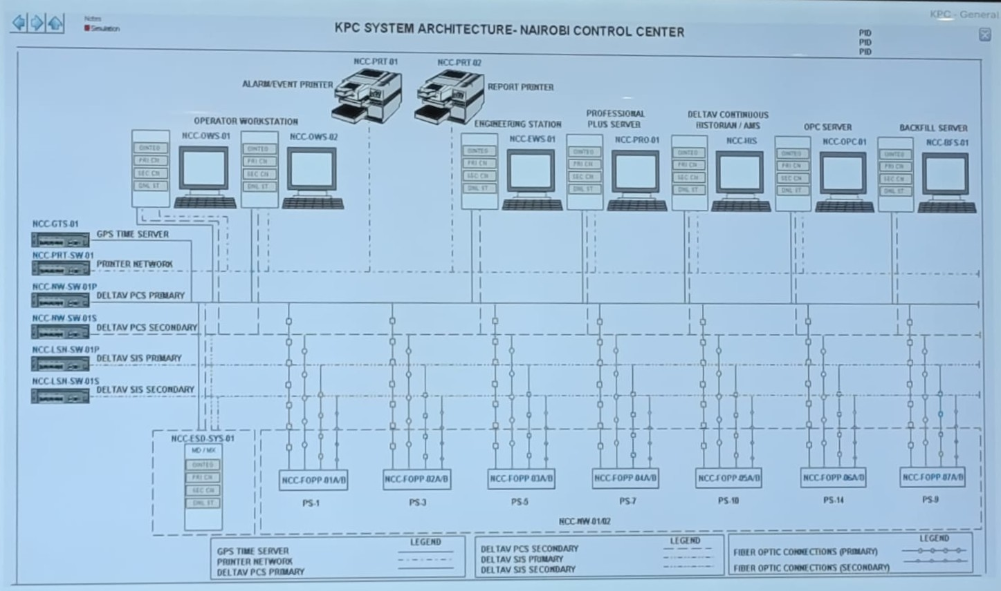

4.3 Assets Management & Maintenance Systems
KPC employs Computerized Maintenance Management Systems (CMMS):
- Preventive and predictive maintenance scheduling
- Asset lifecycle tracking
- Downtime monitoring
Impact:
- Improved operational efficiency
- Reduced equipment failure risks
4.4 Revenue Management & Financial System Integration
KPC integrates financial systems with operations:
- Automated billing and invoicing
- Revenue tracking linked to petroleum throughput
- Integration with banking/payment platforms
Impact:
- High financial transparency
- Reduced revenue leakage
4.5 ICT Infrastructure
KPC has a robust ICT backbone:
- Tiered data centers (primary + disaster recovery)
- Fiber optic connectivity across pipeline network
- Cloud and on-prem hybrid infrastructure
Impact:
- High availability and uptime
- Strong disaster recovery strategy
4.6 Cybersecurity framework
KPC applies layered security:
- Firewalls, IDS/IPS
- Endpoint protection
- Role-Based Access Control (RBAC)
- Regular audits and compliance (likely ISO 27001 aligned)
Impact:
- Strong perimeter and internal controls
- Security awareness culture
4.7 Data Governance & Reporting Mechanisms
KPC demonstrates:
- Structured data governance policies
- Centralized reporting dashboards
- Business Intelligence tools

Impact:
- Data-driven decision making
- Consistent reporting standards

4.8 Implementation Strategies and Lessons learned
KPC implementation approach includes:
- Phased rollout
- User training and onboarding
- Vendor collaboration
- Continuous improvement cycles
Impact:
- Reduced system resistance
- High adoption rates

5.0 Findings and Analysis
5.1 Best practices identified
- A scalable and modular system architecture in place
- Well established ICT Infrastructure
- Security controls and policies in place
- Continuous monitoring of the systems
- Cybersecurity measures in place
- Training and staff awareness done regularly
5.2 Challenges
- Limited ICT budget
6.0 Lessons learnt
The benchmarking exercise revealed several important lessons:
- Systems should be designed with scalability in mind
- Data is key
- Change management needs to be done
- Process should enhance decision making
- Don’t acquire legacy systems
- User involvement is critical for successful adoption
- Continuous system monitoring and updates are essential
- Build capacity
- Security-by-design is essential and must be built-in, not added later.
- Automation of workflow minimizes human error and corruption risks.
- Use standards and interoperable technologies.
- Business continuity must be guaranteed.
- Capacity building and user training drive successful system adoption.
- Document verification mechanisms are necessary to ensure authenticity and prevent fraud.
7.0 Recommendations
Based on the findings, the following recommendations are proposed:
- Adopt a scalable and modular system architecture
- Ensure infrastructure is up to date
- Strengthen data security measures
- Provide comprehensive user training
- Establish clear system governance structures
- Plan for comprehensive data backup and recovery, system expansion and upgrades
- Establish a strong data governance framework with centralized data management.
- Strengthen cybersecurity with MFA, encryption, and regular audits.
- Introduce digital document verification (e-signatures, QR codes).
- Deploy real-time dashboards and analytics tools for monitoring and decision-making.
8.0 Conclusion
The benchmarking exercise provided valuable insights into the design, implementation, and management of effective system. By analyzing an existing system, key strengths and weaknesses were identified, offering practical lessons for the development of UPEMMIS.
The recommendations outlined in this report will guide the enhancement of the Terms of Reference and support the development of a robust, efficient, and sustainable system.

